# **COMP3702: 2016 exam answers**

## [**UQAttic**](http://uqattic.net)

## **Get more out of your study time. Join UQAttic's revision chat.**

#### [**Other exams**](https://drive.google.com/drive/folders/0Bzh9QxUQUKpDZlIxNlRQdXhEYUU)

### Please **contribute** to these documents.

### If you're looking for an effective way to familiarise yourself with the course material, you can't go past collaborating with fellow students. We have laboured to put these up, and so at the very least point out where you think we are wrong!

### You'll get more out of the course, you'll do better in the exam, and other students will benefit from your input as well.

### To get editing permissions, simply go to the [chatroom](http://uqattic.net) and provide us with your Google Account address.

### **Style.**

### Type answers in blue beneath each question.

### If you're unsure of your answer, highlight your answer text then hit Ctrl+Alt+M to create a comment beside the text. Once you're satisfied with the answer, click the "Resolve" button on the comment.

### If you want some extra explanation from someone else on their answer, highlight the other person's answer and repeat the procedure above.

### **Communicate.**

### Head over to [uqattic.net](http://uqattic.net/) and click "Chat Now!". You'll find a chatroom full of students just like you. Talk about a revision document (like this one) or swap prep tips. If you have your own IRC client, point it to irc.uqattic.net, port 6667, channel #attic.

### 

1.Suppose you want to find the shortest path between any two vertices in a weighted undirected graph. The graph has 100,000 vertices and an average degree of 50 edges per vertex. Mr. Search said that in this problem, A∗ with any consistent heuristic will be the best search strategy. Do you agree with Mr. Search? Please explain your answer.

A* will always be optimal, but heuristic may potentially be useless. E.G if heuristic h(N) = 0 for all nodes N

### 

### 

2.Mr. M is moving house. He has moved almost all of his furniture, except for a sofa. He has been having difficulties in moving the sofa out of his old apartment, because the size of the sofa is quite large, compared to the size of the corridor leading to the front/back door of the apartment. He heard about motion planning and thought he might be able to figure out how the sofa should be moved out of the apartment by framing the problem as a motion planning problem. Unfortunately, he does not know how to frame this problem. To help Mr. M in framing the sofa moving problem as a motion planning problem, please

1. Define and explain the configuration space of the problem.

The configuration space would have 6 dimensions. 3 Defining the X, Y, Z shift of the couch, and 3 more defining the angle of rotation around each axis. (Roll, Pitch, Yaw).

1. Define the constraints for a valid path in this problem.

Sofa can not collide with any objects. Limit on the height axis - cannot be less than 0, cannot be too high (higher than one can lift).

3.Someone has just broken into Alex’ apartment and took his precious laptop. You have been hired to help Detective D solve the mystery. Based on the criminal history in the city, Detective D has identified that the crime must be the work of either Angelo, Bruno, Carlo, David, or any combination of them. Detective D also knows the following:

* If David broke into the apartment, Bruno and Carlo must commit the crime with David.
* Carlo is the one who broke into the apartment only if Angelo and Bruno were not involved in the crime.
* David broke into the apartment if and only if Carlo committed the crime with him and Angelo did not.
* If David broke into the apartment, then, if Carlo did not commit the crime with him, then Angelo broke into the apartment with David.
* Carlo broke into the apartment provided that David did not, but, if David broke into the apartment, then Bruno did not.

Your job is to help Detective D understand how many people may be involved in this crime. To this end, please answer the following questions:

1. Define each of the above sentence as a propositional logic sentence and convert them to CNF (if they are not already in a CNF format).  
   Let A be angelo commited the crime  
   Let B be Bruno commited the crime  
   Let C be Carlo commited the crime  
   Let D be David commited the crime  
   →∧∨ ↔  
   There are 5 sentences:  
   1. D → B ∧ C  
   2. (~A ∧ ~B) -> C   
   3. (D ∧ ~A) ↔ C  
   4. D → (~C → A) (Also could written as (D ∧ ~C) → A)  
   5. (~D → C) ∧ (D → ~B)  
     
   Converting each to CNF:  
   1. (~D ∨ B) and (~D ∨ C)  
   2. (A v B) v C  
   3. (~C v A) v D and (~D v C ) v A (Others interprety this as D <-> (~A ^C), fyi)  
   4. (~D ∨ C) ∨ A  
   5. (D ∨ C) and (~D ∨ ~B)

T: I fixed some of these answers above if anyone notices things are different. I think they’re correct

1. Is it possible that three people of the group are involved in the crime? Please explain how you come to the answer.

Using a truth table, try each combination of 3 trues and a false (there are 4  
 permutations). Until you find a contradictory CNF sentence.

ACB is a valid answer as per DPLL, ~D, B doesnt matter but just say yes and it works, very quick to prove as D shows up everywhere so just fix that and it all drops out

1. Detective D told you that you can always find the minimum number of possible perpetrators dusing GSAT. Do you agree with him? Please explain why you agree or why you disagree.

To elaborate further, GSAT as it stands alone (from lecture slides) is not enough to solve this problem as you cannot guarantee it will do anything because it is a random algorithm. I.e. not complete. Also, it terminates as soon as it finds anything satisfiable so how would you find the minimum?   
  
You would have to loop over all possible numbers of assignments to see if you can find a minimum that works, worst case complexity would be very high.

4.Suppose the current AND-OR tree that your agent has at the moment is as presented in Figure 1. Has your agent found a solution to the non-deterministic problem it is trying to solve by generating this AND-OR tree? Please explain your answer. Hint: Assigning labels to the nodes of your tree should be part of your explanation.

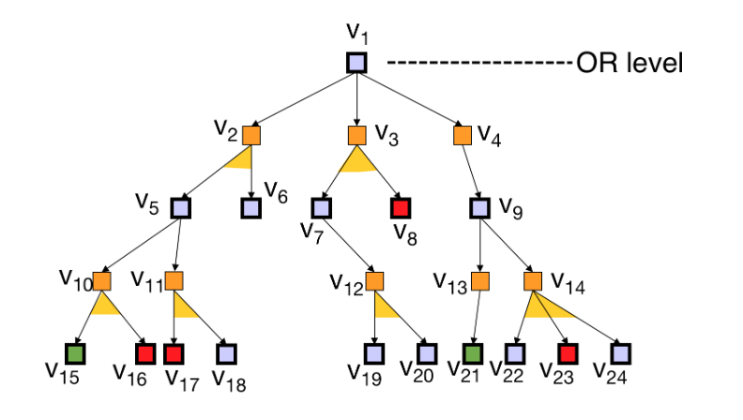

Figure 1: An AND-OR tree. Purple means a non-leaf OR node or a leaf OR node that can still be expanded. Orange means a non-leaf AND node. Green means a goal node. Red means a non-goal terminal node

Yes, there is a solution to this problem. An AND node (yellow in this case) is considered solved if all its children are also solved, as the agent has no control over the next state at this point. An OR node (purple in this case) is considered solved if one of its children is solved, as the agent has control over its own actions. In the case of this tree, the AND node v13 is solved, as it has only one option which is solved, this mean the OR node v9 is also solved as one of its children is solved, making V4 solved, making V1 solved.

TLDR: V13 V9 V4 V1

5.Darth Vader has kidnapped Luke Skywalker and placed him in one of the cells in his dungeon. To free Luke, R2D2 entered Vader’s dungeon. The dungeon contains three cells, two of the cells contain Vader’s monsters and one contains Luke. When R2D2 enters the dungeon, it assumes that Luke can be in any room with equal probability. Breaking into a cell with a monster inside, would cause R2D2 to be attacked by the monster and incur a cost of $2,000 for reparation. Breaking into a cell where Luke is, would free Luke and R2D2 will be rewarded $1,000. R2D2 can scan the dungeon to figure out where the monsters are. However, each scan incurs a cost of $ 300. Since the monsters are all hyper-active, a single scan of the dungeon can identify the cell where Luke is, with 80% accuracy. All false scanning results are equally probable. How many times should R2D2 scan the dungeon before it opens the door most likely to be occupied by Luke? Please use the Maximum Expected Utility, where the utility is based on monetary gain, to explain your answer.

3 Rooms:

S: {S1 : Luke in room 1,  
 S2: Luke in room 2,  
 S3: Luke in room 3}  
A: {Scan, open1, open2, open3}  
O: {Luke in 1, Luke in 2, Luke in 3}  
T: a = scan: P(St + 1 = S1 | St = S1, at = scan) = 1.0

|  | S1 | S2 | S3 |
| --- | --- | --- | --- |
| S1 | 1 | 0 | 0 |
| S2 | 0 | 1 | 0 |
| S3 | 0 | 0 | 1 |

Z: a = scan  
…

R:

|  | Scan | Open1 | Open2 | Open3 |
| --- | --- | --- | --- | --- |
| S1 | -300 | 1000 | -2000 | -2000 |
| S2 | -300 | -2000 | 1000 | -2000 |
| S3 | -300 | -2000 | -2000 | 1000 |

Beliefs:  
b1(S1) = P(St + 1 = s1 | ot = h-1, at = Scan, b0)  
= P(Ot = h - 1 | St + 1 = S1, At = Scan)  
= P(St + 1 = S1 | St = S3, At = scan) bt(S3))  
= 0.8 (1 * ⅓ + 0 * ⅓ + 0 * ⅓)  
= 0.8/3  
  
b1(S2) = 0.1(0 * ⅓ + 1 * ⅓ * 0 * ⅓)  
= 0.⅓

b1(S3)

...

6. Value iteration algorithm (presented in Algorithm 1) is a basic method for solving MDP. It is known that POMDP is MDP in the belief space, which means the value iteration algorithm above will also be a valid algorithm for solving POMDP problem, of course given the appropriate parameters. Please answer the following questions.

1. Explain what should the parameter S in Algorithm 1 be if we want to solve a POMDP problem?  
   The beliefs
2. Define and explain what should the parameter T in Algorithm 1 be if we want to solve a POMDP problem?

Transition Function for POMDP: b’ = T(b,a,o) where b is the current belief , a is the action required to move to the next belief and o being the observation function.

1. A single Bellman backup operation for MDP takes O ( | A || S | 2 ) time. Please compute the worst case time complexity of a single Bellman backup operation for POMDP, assuming the belief space is discretized uniformly, with each dimension discretized into m uniform range. Please define your complexity with respect to the size of the state space S ′ , action space A ′ , and observation space Ω , of the POMDP problem

Complexity of the value iteration for the POMDP problem : O(m^|S|-1(|o| |S|^2 |A|)